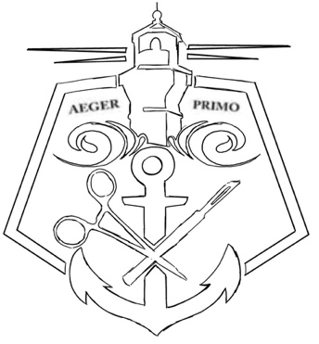

CA-SA of AST Annual Conference Agenda

6:30-7:30am – Registration Check-In + Breakfast
7:45-8:00am – Welcome Ceremony
Fernando Mendoza, President of CA-SA
Military Recognition/ Color Guards + National Anthem
8:05-8:55am – Public Policy and Advocacy -Stephanie Whalum (Government Affairs of AST)
9:00- 9:50am –New Realities in Surgical Training- Justin Barad, MD (Osso VR)
A.M. BREAK

10:00-10:50am –Pediatric Neurosurgery: Key Concepts in Shunt, Endoscopy and Pediatric Patients - Eisha Christian, MD (Kaiser Permanente)
10:55-11:40am– Business Meeting Part 1

LUNCH – 11:45am – 12:45pm

12:50-1:40pm –Enhancing Communication Between SPD & the OR- Harry Mullen, CRCST (President, California Central Service Association)
1:45- 2:25pm –Parafascicular Subcortical Surgery using a channel based approach -Gabriel Zada, MD (Keck Hospital of USC)
2:30-3:20pm –Hearts with Hope: Healing Hearts Abroad-Juan Alejos, MD UCLA (Hearts with Hope)

P.M. BREAK

3:30-4:20pm –Immediate-Use Steam Sterilization- Michele McKinley (Steris)
4:25-5:00pm – Business Meeting Part 2
- Voting Results Announced
- Open Forum Questions/ New Business
- Closing Ceremony

